JAGJIT SINGH BILKHU

T00533766

Lab 2 – Process Forking

COMP 3540

**Once the first program is typed, and executed, answer the following questions**

* 1. **If you try to print a message after the *exec\** call, does it print it? Why? Why not?** 
     1. It does not print the message after the execl call. This is because the child process leaves the c program source code to the CAT command execution and exits after the command is completed.
  2. **Who is the parent of your executable program?** 
     1. The bash process is the parent of the program. The bash process and the pid printed in the c program are equal
  3. **How would you change the code so that the child and parent run concurrently?** 
     1. Remove the WAIT statement to allow the parent to run without waiting for child

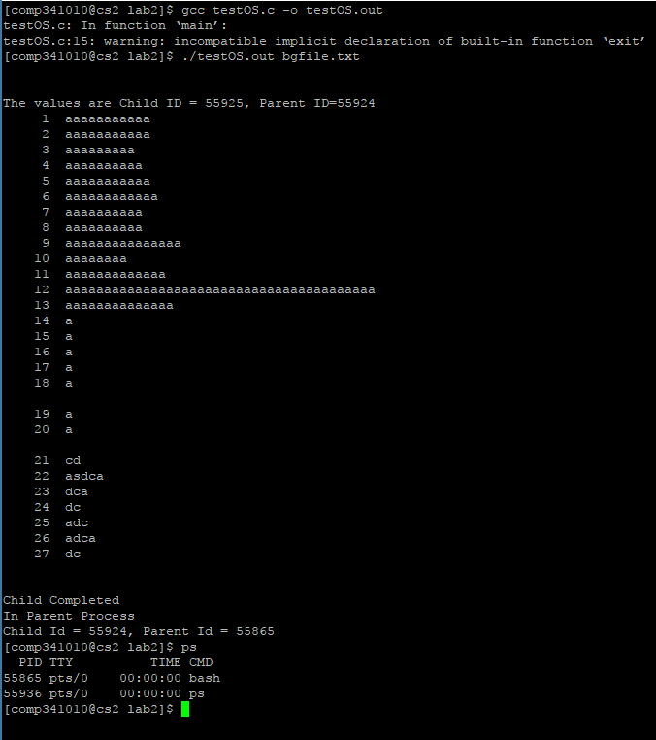

* + 1. **Run a process in background**
    2. **Run a process in foreground**
    3. **Call the process from background to foreground**
    4. **Kill the process**
    5. **Show the process status**

